Announcing: HERStory

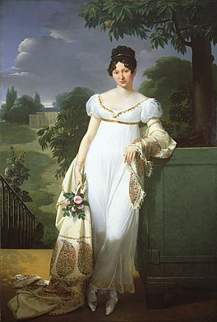**Did you ever wonder what women’s lives were like 100 years ago? What did they wear, where did they live, what was expected of them?**

**Join us at the Dunn County Museum in Dunn Center at 2 PM MT on Sun. July 7 for a presentation of Women’s History of the 1800’s. Using a collection of 28-inch lady dolls dressed in costumes of era, we will discuss how women’s lives and costumes have evolved through the years.**